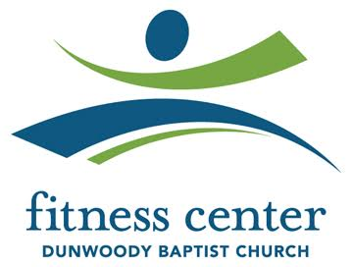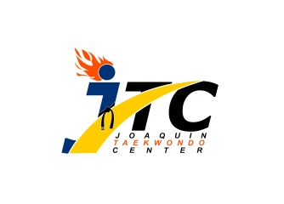

# Taekwondo Classes

## Joaquin Taekwondo Center

Fitness Center at Dunwoody Baptist Church

1445 Mt Vernon Rd, Dunwoody GA 30338

PH : 770-557-9325

[Jtc.duwoody@gmail.com](mailto:Jtc.duwoody@gmail.com)

<https://www.facebook.com/JTCDunwoody/>

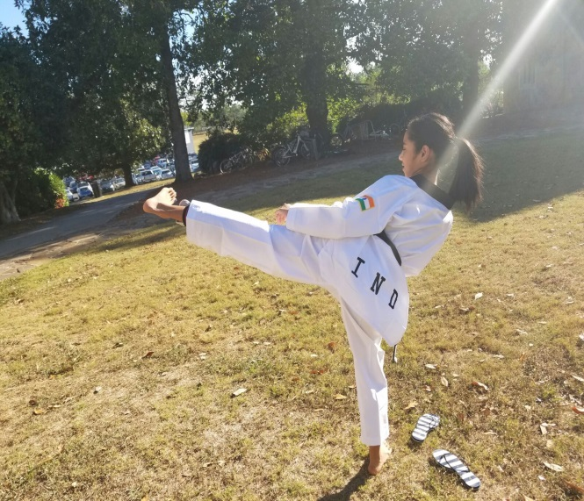

**Benefits of TaeKwonDo**

* Improve Focus
* Self-Discipline and Responsibility
* Respect parents and others
* Build Self-Confidence and Self-Control
* Self-Defense / Anti-Bullying

**About the Master Instructor**

* 5th Degree Black Belt
* 2017 US OPEN Medalist
* Experienced in training champions

**Details**

* Classes on Thursdays and Fridays at 5:15pm
* Monthly tuition - $90
* Bring the flyer for a $10 off first month